**NETWORKING & SYSTEM ADMINISTRATION LAB**

**Experiment No: 25**

**Name: Silvia Thomas**

**Roll No: 38**

**Batch: B**

**Date: 23/05/2022**

**Name: Silvia Thomas**

**Roll No: 38**

**Batch: B**

**Date: 23/05/2022**

**Aim**

## Setting Up an Apache Container.

**Procedure**

Step 1:

**$ sudo docker run -dit --name tecmint-web -p 8080:80 -v /home/user/website/:/usr/local/apache2/htdocs/ httpd:2.4**

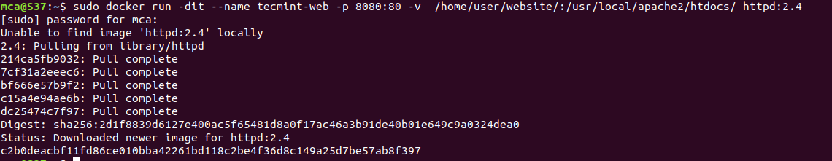Pull Docker Apache Container

At this point, our Apache container should be up and running.

Step 2:

**$ sudo docker ps**

Check Apache Docker Container

**Step 3:** Now let’s create a simple web page named docker.html inside the /home/user/website directory.

**$ sudo gedit /home/user/website/docker.html**

Add the following sample HTML content to the file.

<!DOCTYPE html>

<html lang="en">

<head>

<meta charset="UTF-8">

<title>Learn Docker at Tecmint.com</title>

</head>

<body>

<h1>Learn Docker With Us</h1>

</body>

</html>

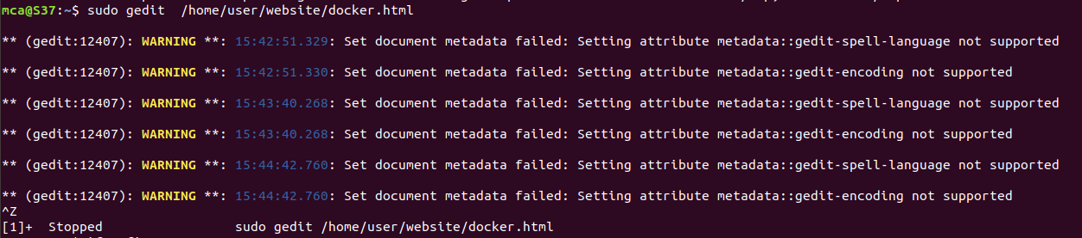

Step 4: Next, point your browser to **Server-IP:8080/docker.html** (where **Server-IP** is your host’s public IP address). You should be presented with the page we created previously.

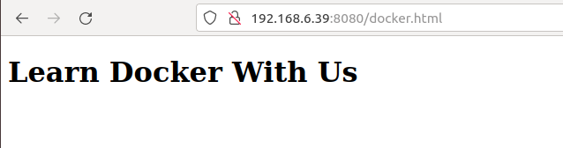Check Apache Page

Step 5: If you wish, you can now stop the container.

**$ sudo docker stop tecmint-web**



Step 6: Remove it:

**$ sudo docker rm tecmint-web**



Step 7: To finish cleaning up, you may want to delete the image that was used in the container (omit this step if you’re planning on creating other **Apache 2.4** containers soon).

**$ sudo docker image remove httpd:2.4**

